**ASSIGNMENT-8.4**

Parsing XML files using pig

Convert the XML file into CSV and save the CSV output in a file using pig.

**STEPS**

* Loading the xml file as x

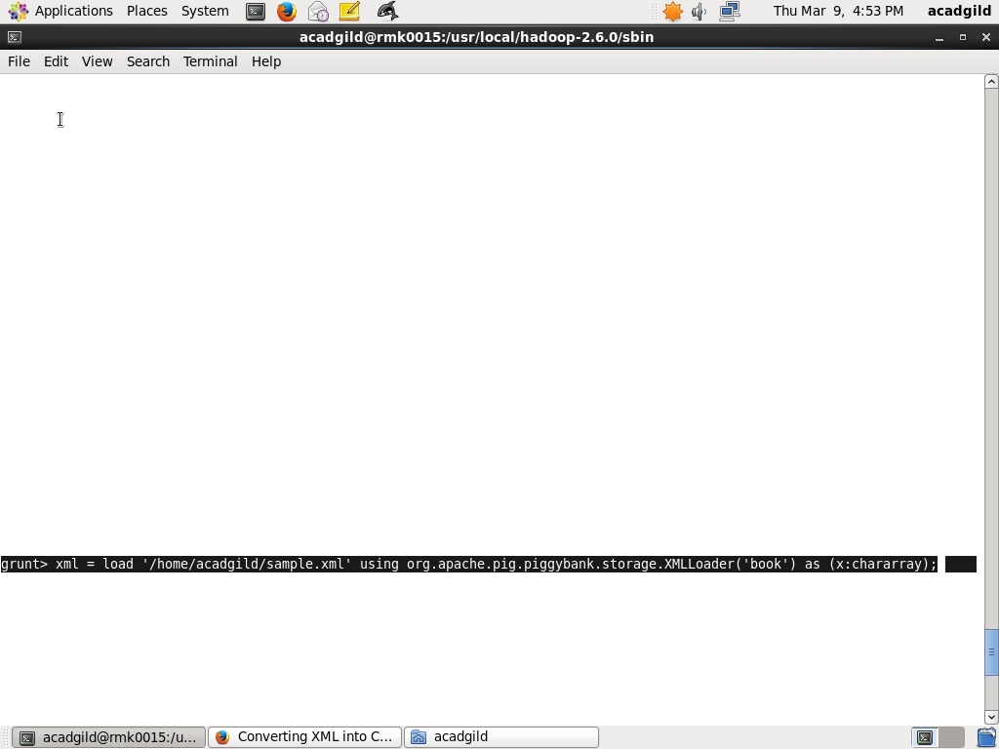

1. Making the XML data into a single line data
2. Removing tag lines extracting only its data
3. Flatten the data
4. Storing into a separate file

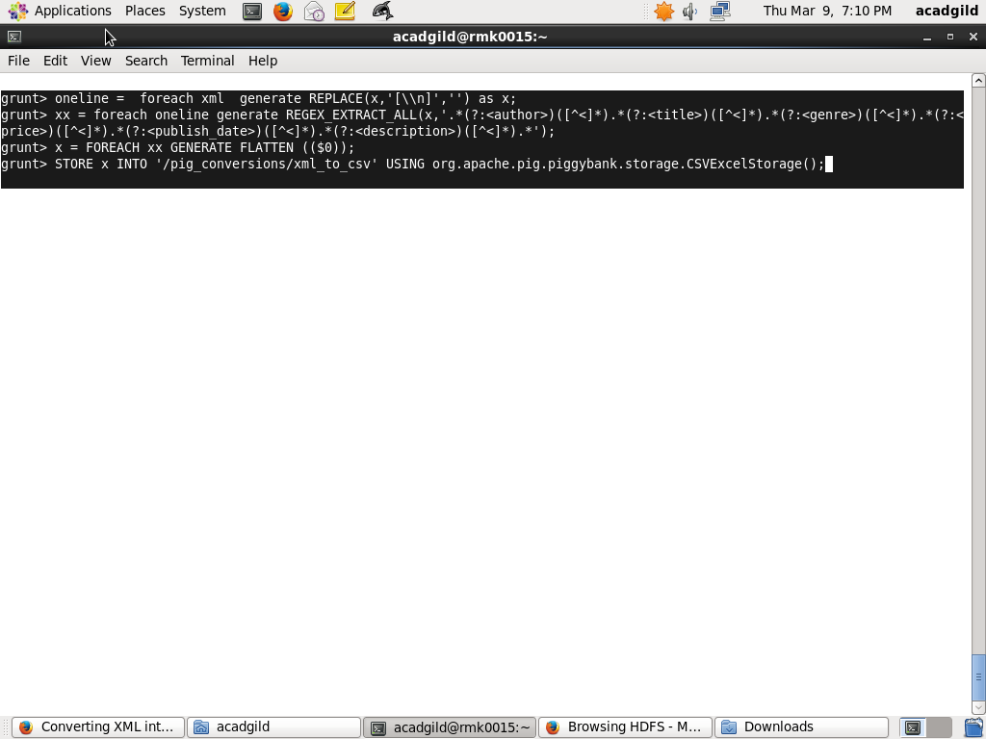

OUTPUT FILE IN CSV 